Studio # 1 & 2

Name and Student Id: Nicolas Pallant 28785959

Self-Evaluation:

|  |  |  |  |  |  |
| --- | --- | --- | --- | --- | --- |
| Need Help | Work in Progress | Pass | Credit | Distinction | High Distinction |

Task 1.1:

Visual Studio:

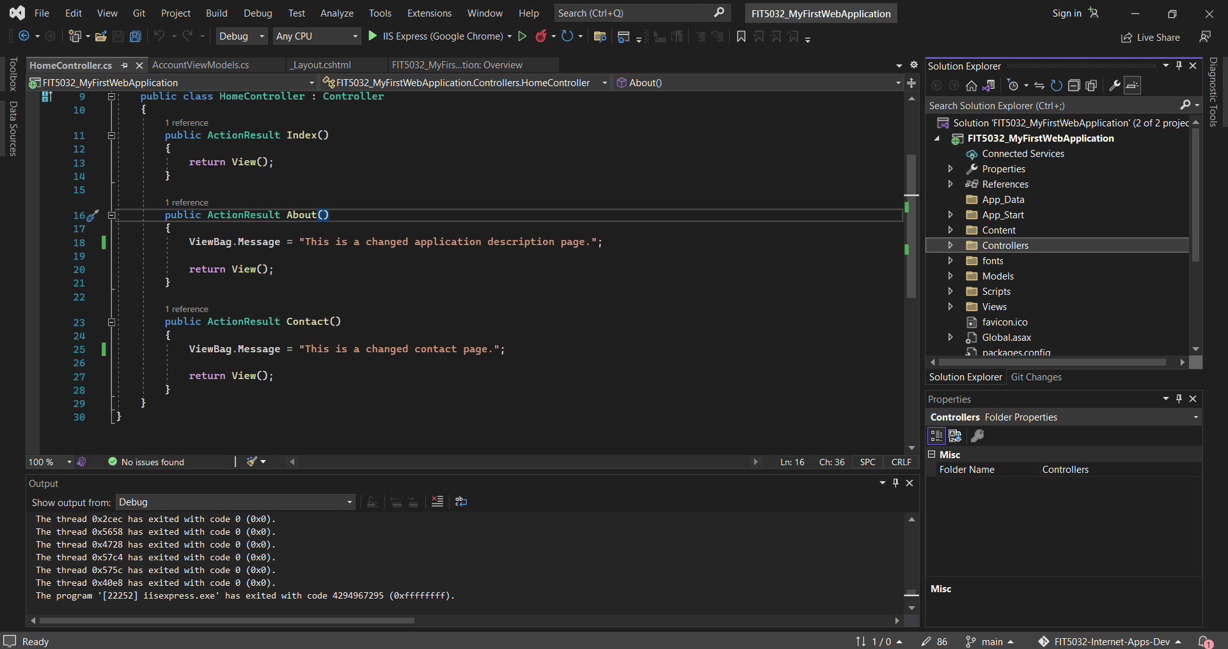

Localhost:

Git Repository:

https://github.com/Ryukawastaken/FIT5032-Internet-Apps-Dev.git

Task 1.2:

5 Different Agile Development IDEs:

Microsoft Visual Studio https://visualstudio.microsoft.com/

JetBrains Rider https://www.jetbrains.com/rider/

Oracle NetBeans https://www.oracle.com/au/tools/technologies/netbeans-ide.html

JetBrains IntelliJ IDEA https://www.jetbrains.com/idea/

JetBrains PyCharm https://www.jetbrains.com/pycharm/

Features of Visual Studio Community Edition:

Breakpoints/Debugging:

* Allows for real-time debugging at multiple points
* Shows status of variables at current point in time
* Allows for stepping over/into/out of for flow visualisation

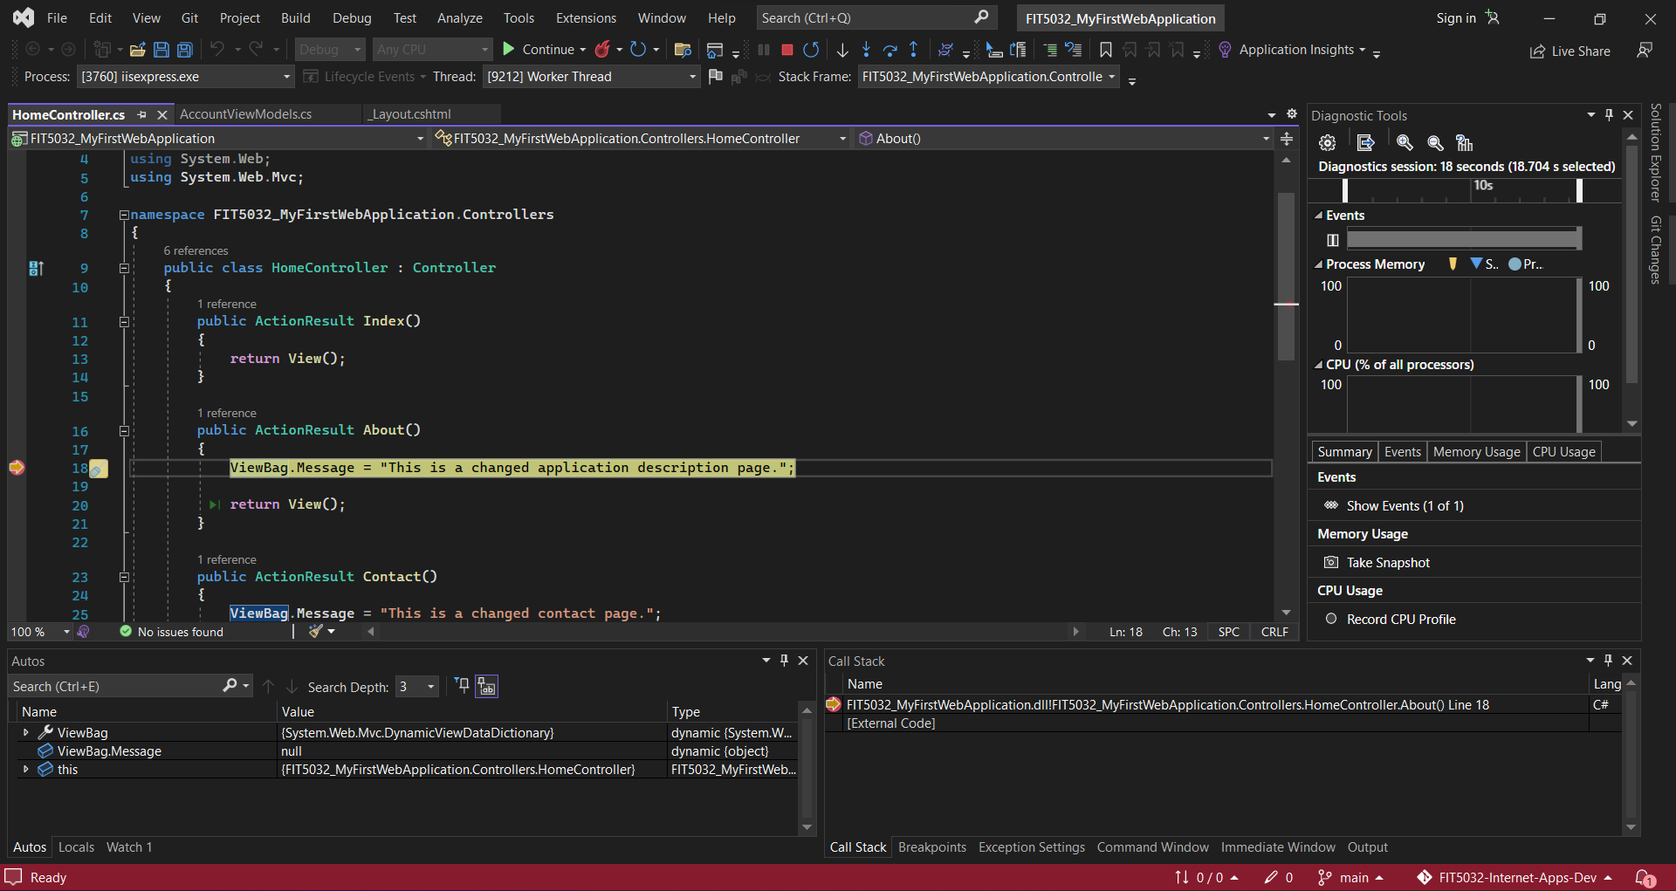

Method Renaming with updated references:

* Allows for renaming in one place and updating of all references to the variable/function
* Can choose to include comments/strings in renaming
* Can preview changes before applying changes

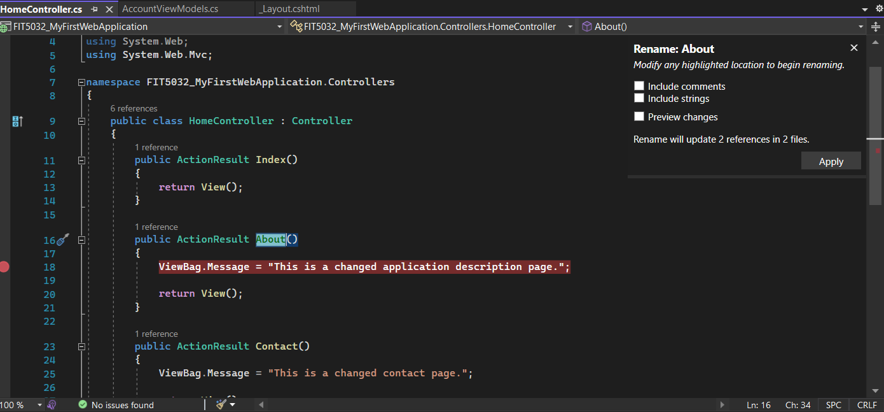

Integrated Git/Version Control:

* Allows the cloning of remote repositories and the management of local repositories
* Allows Pushing and Pulling directly from the IDE
* Allows for Branching and the management of those Branches

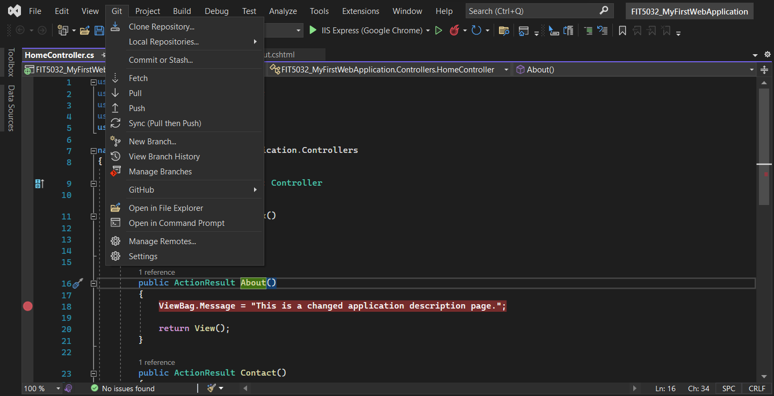

Extension Support:

* Includes support for installation of official and independently made extensions
* Easy to use Extension manager to browse, install, uninstall, and modify extensions

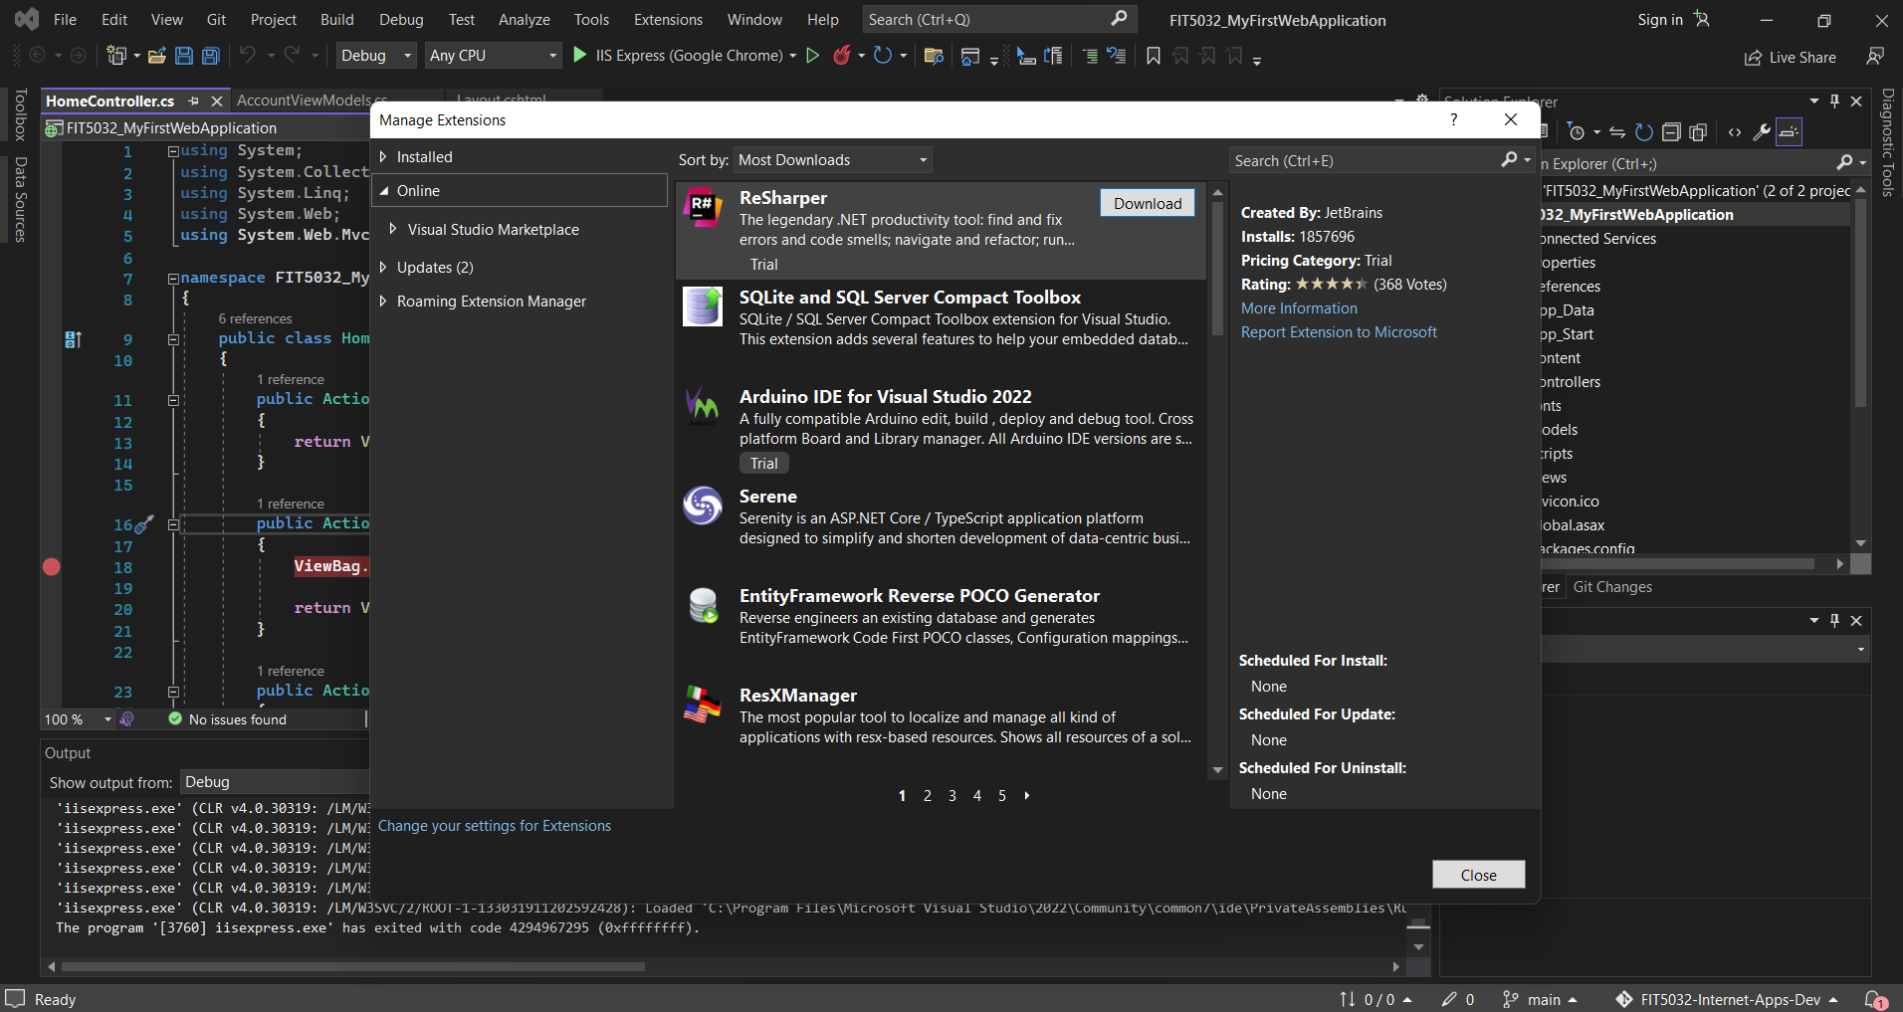

Quick Actions and Refactoring:

* Allows easy fixes of mistakes by recognizing what you may have meant
* Allows quick generation of methods
* Suggests changes to code to fix potential issues

